Counting Uppercase and Lowercase Letters Using LEX
Aim :
To write a LEX program to read a text file and count the number of uppercase and lowercase alphabetic characters.

Pseudocode :
BEGIN
Open input.txt
If file cannot be opened
Print error message
STOP
End if
Set uppercase count = 0
Set lowercase count = 0
Read file using yylex()
For each character
If character is uppercase
Increase uppercase count
Else if character is lowercase
Increase lowercase count
End if
End for
Display uppercase and lowercase counts
Close input file
END

Code :

%{
#include <stdio.h>
int upper = 0;
int lower = 0;
%}
%%
[A-Z] { upper++; }
[a-z] { lower++; }
.|\n ;
%%
int yywrap(void) {
return 1;
}
int main(void) {
FILE *fp = fopen("input.txt", "r");
if (fp == NULL) {
printf("Error opening file\n");
return 1;
}
yyin = fp;
yylex();
printf("Uppercase letters: %d\n", upper);
printf("Lowercase letters: %d\n", lower);
fclose(fp);
return 0;
}
Output :
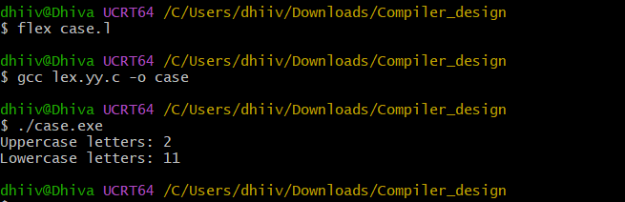

Result :

Thus, the LEX program successfully counts the uppercase and lowercase alphabetic characters in the given input file.

